**Ideation Phase**

**Brainstorm & Idea Prioritization**

|  |  |
| --- | --- |
| Date | 27 June 2026 |
| Team ID | LTVIP2025TMID40771 |
| Project Name | Traffictelligence |
| Maximum Marks | 4 Marks |

**Brainstorm & Idea Prioritization**

Brainstorming provides a free and open environment that encourages everyone within a team to participate in the creative thinking process that leads to problem solving. Prioritizing volume over value, out-of-the-box ideas are welcome and built upon, and all participants are encouraged to collaborate, helping each other develop a rich amount of creative solutions.

**Step-1: Team Gathering, Collaboration and Select the Problem Statement**

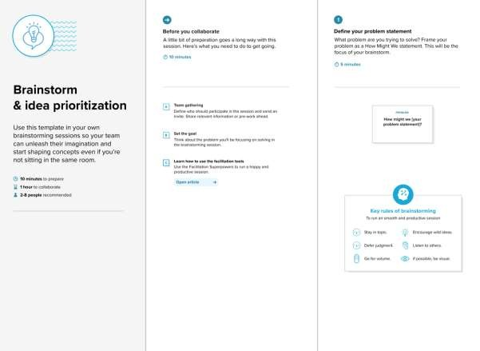

**Step-2: Brainstorm, Idea Listing and Grouping**

**\*\*Ideas**:**

1. **Develop a web app to predict traffic volume using machine learning.**
2. **Integrate real-time weather API for dynamic predictions.**

|  |
| --- |
| 1. **Add a mobile app version for on-the-go access.** 2. **Include historical traffic data for trend analysis.** 3. **Create a dashboard for traffic managers with live updates.** 4. **Offer voice input for hands-free use by drivers.** 5. **Implement notifications for sudden traffic changes.** 6. **Allow users to report road conditions manually.** |
| **\*\*Grouping**:**   * **\*\*Web & Mobile Solutions**: 1,2** * **\*\*Data Integration**: 3, 4** * **\*\*Traffic Management**: 1,2,3,4** |
| **\*\*Prioritization** (e.g., based on feasibility and impact):**   1. **Web app with machine learning (Implemented).** 2. **Real-time weather API integration.** 3. **Dashboard for traffic managers.** |

**Step-3: Idea Prioritization**

